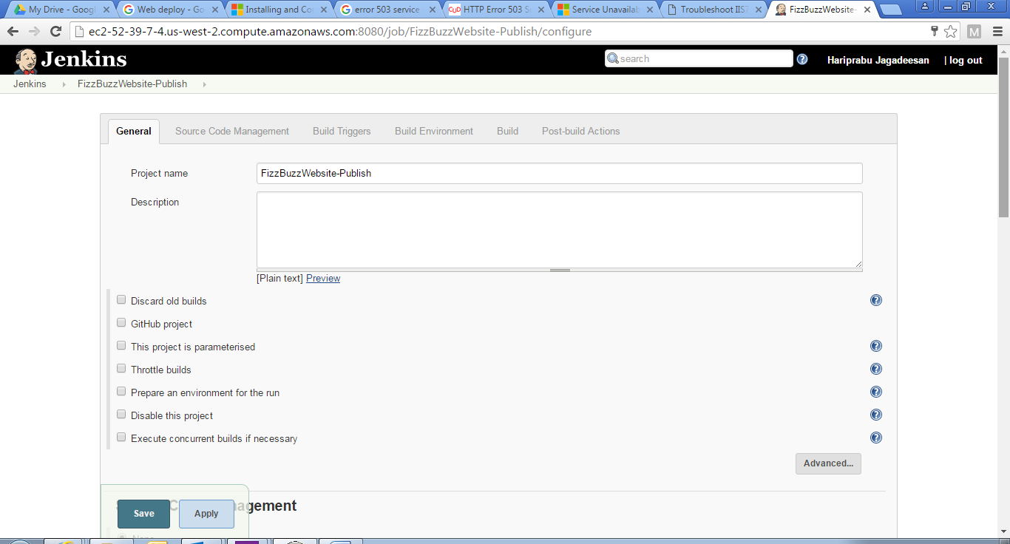

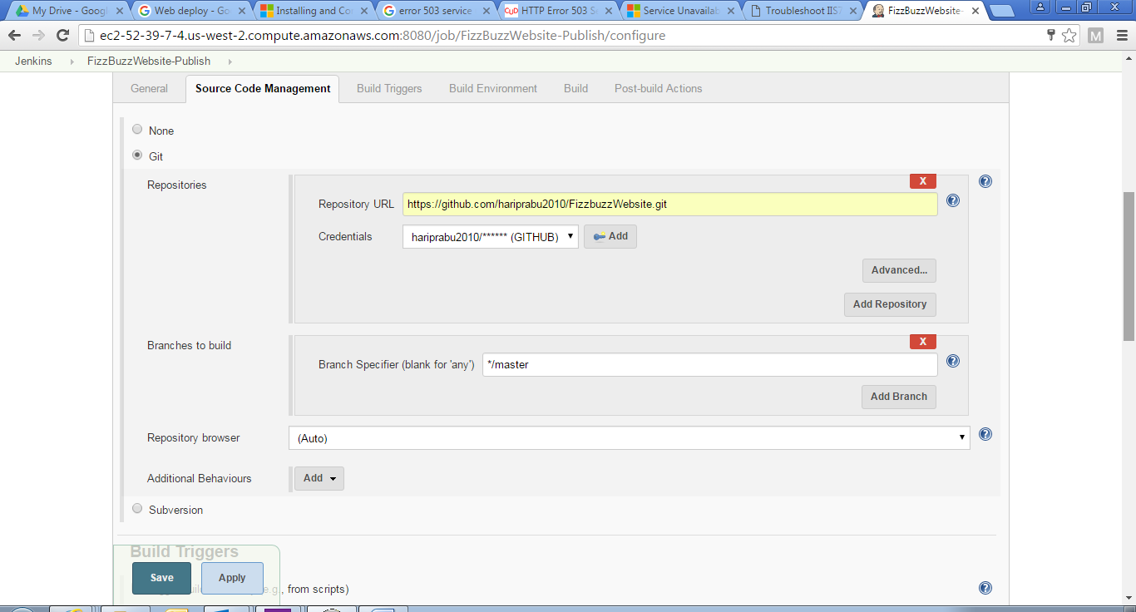

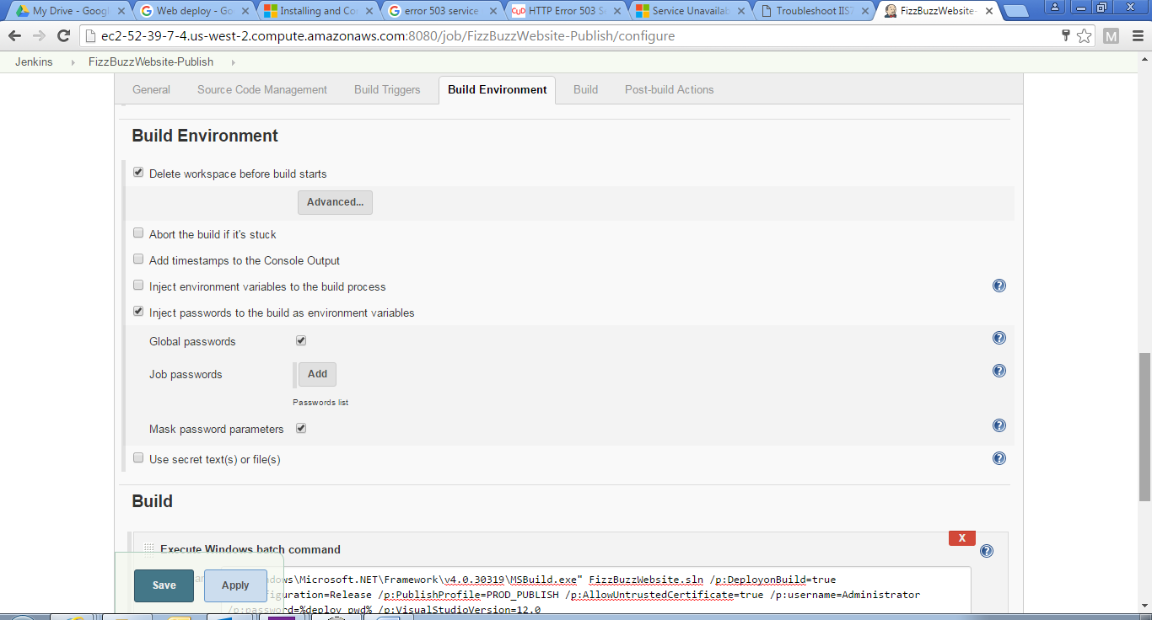

This will use MSDeploy to publish after the build

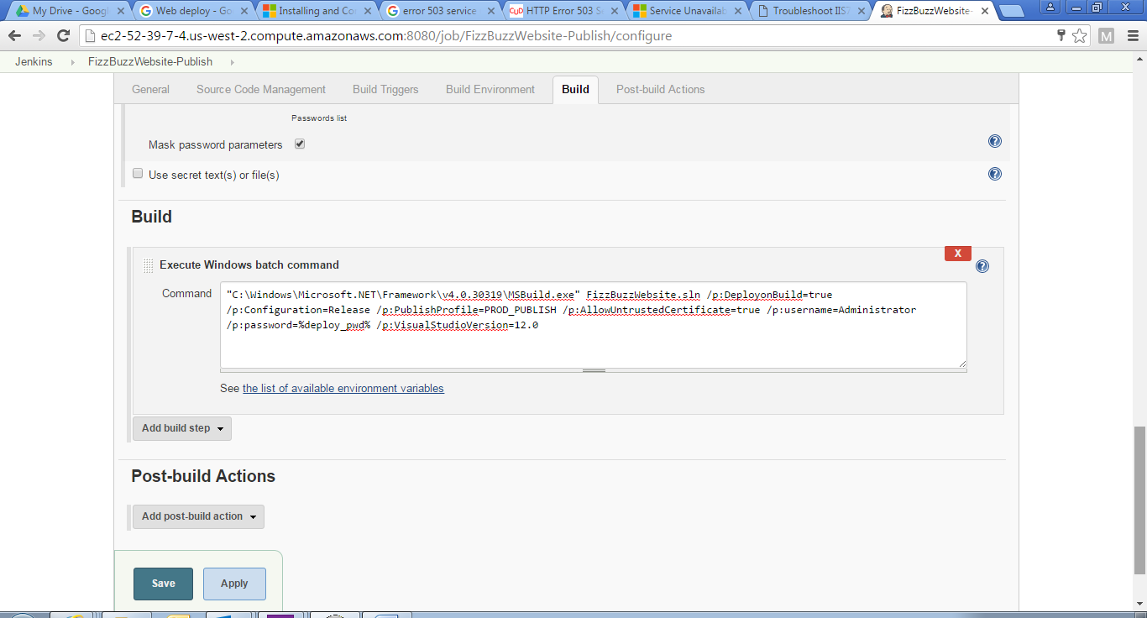

PublishProfile - PROD PUBLISH

<?xml version="1.0" encoding="utf-8"?>

<!--

This file is used by the publish/package process of your Web project. You can customize the behavior of this process

by editing this MSBuild file. In order to learn more about this please visit http://go.microsoft.com/fwlink/?LinkID=208121.

-->

<Project ToolsVersion="4.0" xmlns="http://schemas.microsoft.com/developer/msbuild/2003">

<PropertyGroup>

<WebPublishMethod>**MSDeploy**</WebPublishMethod>

<SiteUrlToLaunchAfterPublish />

<MSDeployServiceURL>**ec2-52-39-7-4.us-west-2.compute.amazonaws.com**</MSDeployServiceURL>

<DeployIisAppPath>**Default Web Site/FizzBuzzWebsite**</DeployIisAppPath>

<RemoteSitePhysicalPath />

<SkipExtraFilesOnServer>**True**</SkipExtraFilesOnServer>

<MSDeployPublishMethod>**WMSVC**</MSDeployPublishMethod>

<UserName>**Administrator**</UserName>

<_SavePWD>**True**</_SavePWD>

<PublishDatabaseSettings>

<Objects xmlns="">

<ObjectGroup Name="DefaultConnection" Order="1" Enabled="False">

<Destination Path="" />

<Object Type="DbDacFx">

<PreSource Path="Data Source=(LocalDb)\v11.0;AttachDbFilename=|DataDirectory|\aspnet-FizzBuzzWebsite-20160501200013.mdf;Initial Catalog=aspnet-FizzBuzzWebsite-20160501200013;Integrated Security=True" includeData="False" />

<Source Path="$(IntermediateOutputPath)AutoScripts\DefaultConnection_IncrementalSchemaOnly.dacpac" dacpacAction="Deploy" />

</Object>

<UpdateFrom Type="Web.Config">

<Source MatchValue="Data Source=(LocalDb)\v11.0;Initial Catalog=aspnet-FizzBuzzWebsite-20160501200013;Integrated Security=SSPI;AttachDBFilename=|DataDirectory|\aspnet-FizzBuzzWebsite-20160501200013.mdf" MatchAttributes="$(UpdateFromConnectionStringAttributes)" />

</UpdateFrom>

</ObjectGroup>

</Objects>

</PublishDatabaseSettings>

</PropertyGroup>

<ItemGroup>

<MSDeployParameterValue Include="$(DeployParameterPrefix)DefaultConnection-Web.config Connection String" />

</ItemGroup>

</Project>